|  |  |  |  |  |  |
| --- | --- | --- | --- | --- | --- |
| Date | Sept 23, 2022 | | | Tester Name | Alyssa Johnson |
| Environment | Penfax - Test | | | Login used |  |
| Operating System | Select OS | Version: | Update: | | |
| Software Used | Select Software | Version: | Update: | | |
| Select Software | Version: | Update: | | |
| Release version | 22.3.0 | | | | |
| Title | E23.06 | | | | |
| Test Type | Regression | | | | |
| Test Scenario | Process VPB monthly payment production | | | | |
|  |  | | | | |
| Expected Results | Process VPB payroll.   * Ensure that the PIT runs successfully and any warnings/errors are accurate * Check a few members that all payments are processed successfully and taxed correctly. * Check a non-resident (if applicable) to confirm taxes * Verify that payments are separated & nothing in payroll shows as a vendor payment * Verify that the Cheque extract & EFT extract are generated | | | | |
| Pass/Fail | Pass | | | JIRA# | N/A |

To get payroll to run, we have to change this screen to fit with the date we want it to run.

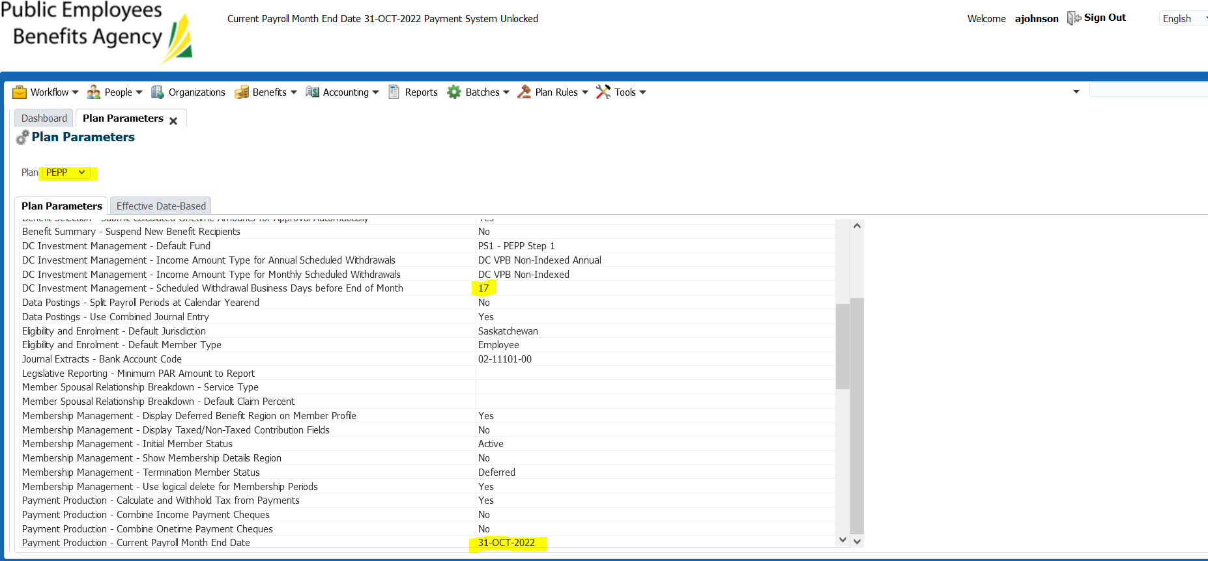

1. Change scheduled business day’s before end of month to match with the business day’s tomorrow will be.
   1. Today is Oct 5, count Oct 6th as 1 and then skip weekends and stats and enter that number
2. This month September payroll didn’t run, still have to change the current payroll month to October last day of the month (even if September’s wasn’t run) as it won’t let us run payroll for a previous month.

Wait for overnight processing, the funds will come out of the VPB members investment accounts overnight then payroll can be run through Payment production the following day.

Next Day:

Confirm the money has been w/d from investment account & overnight batch ran correctly

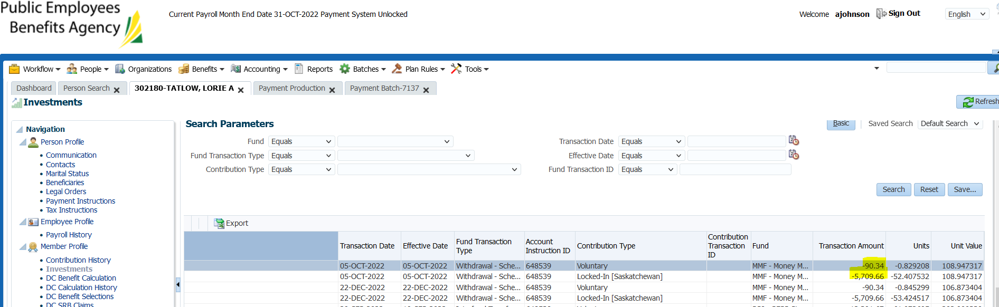

*\*note this test case December payroll (with December catchup was previously run). September payroll was also missed/will not show.*

Run the Test in Payment Production for PEPP – confirm month end date is showing the correct month (eg. Current month).

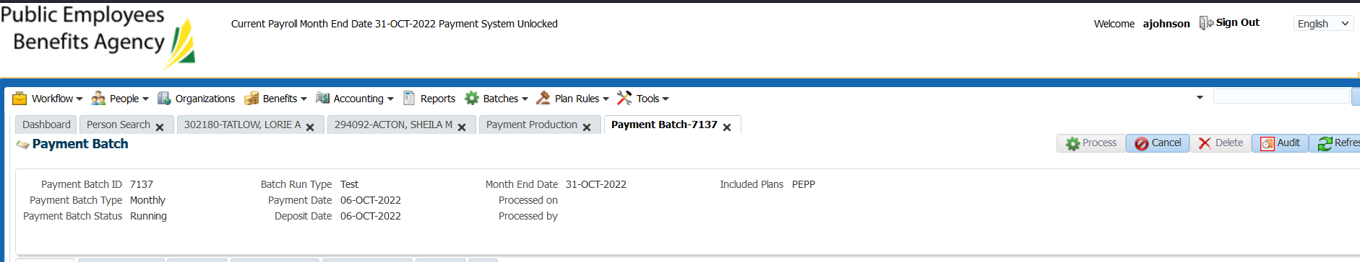

Run the Payment Batch  
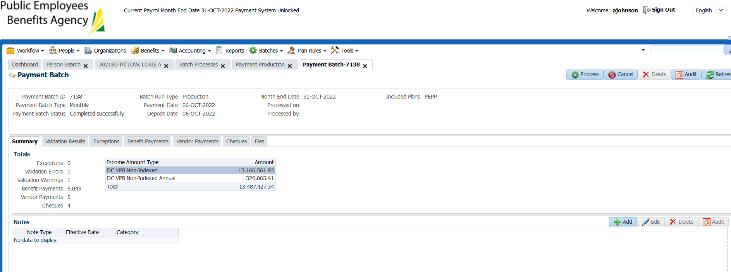

Add wire transfer fee (if applicable) – test case 16.31b

SID: 302180 - Lorie Tatlow

-specified order scheduled payment

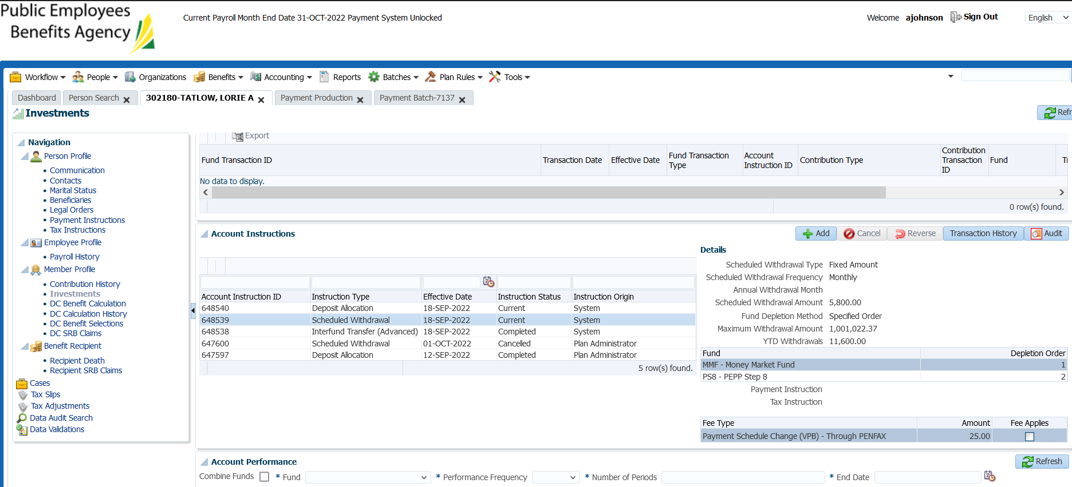

Confirmed specified order for this member:

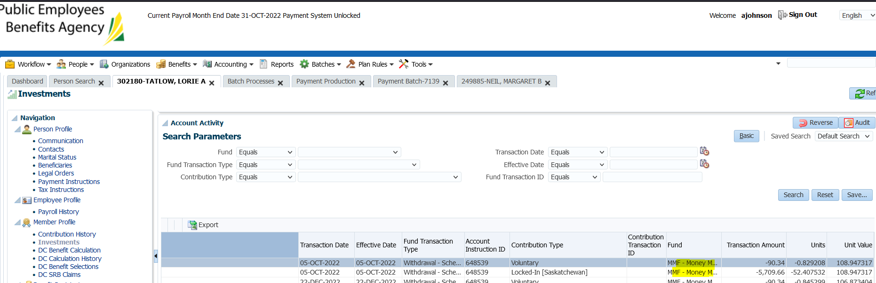

Confirmed EFT file, banking info matches Penfax info:

*\*there was an instance in the past where these were all skewed by one line.*



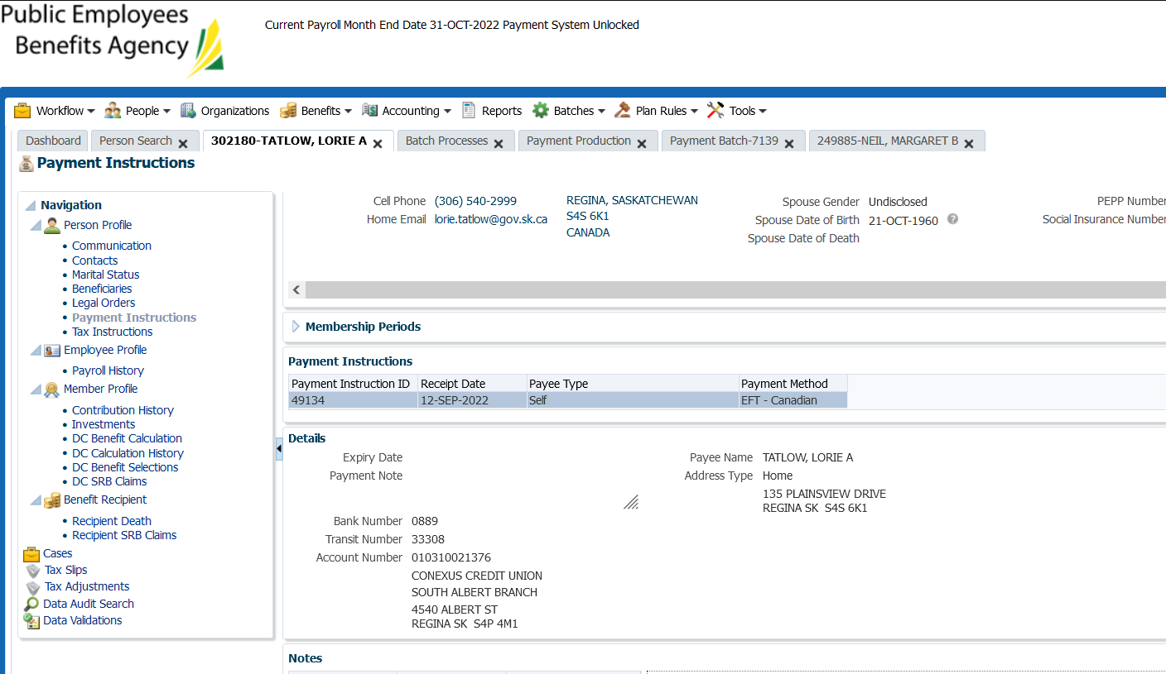

Confirmed one member that is via cheque

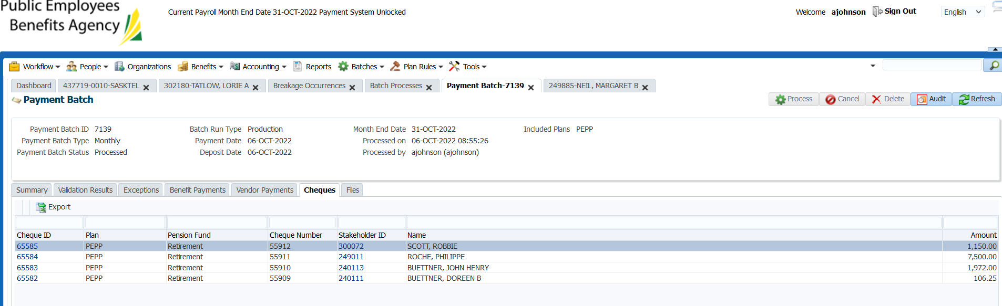

SID 249011

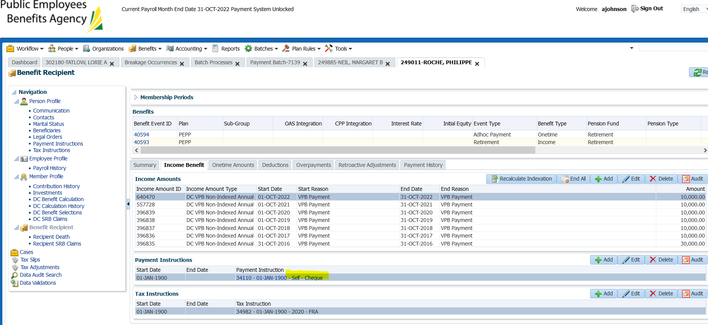

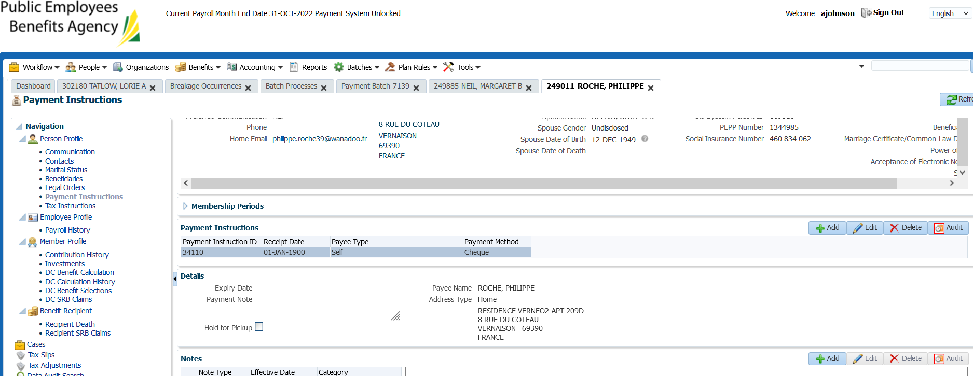

Address and amount are correct on the cheque file.

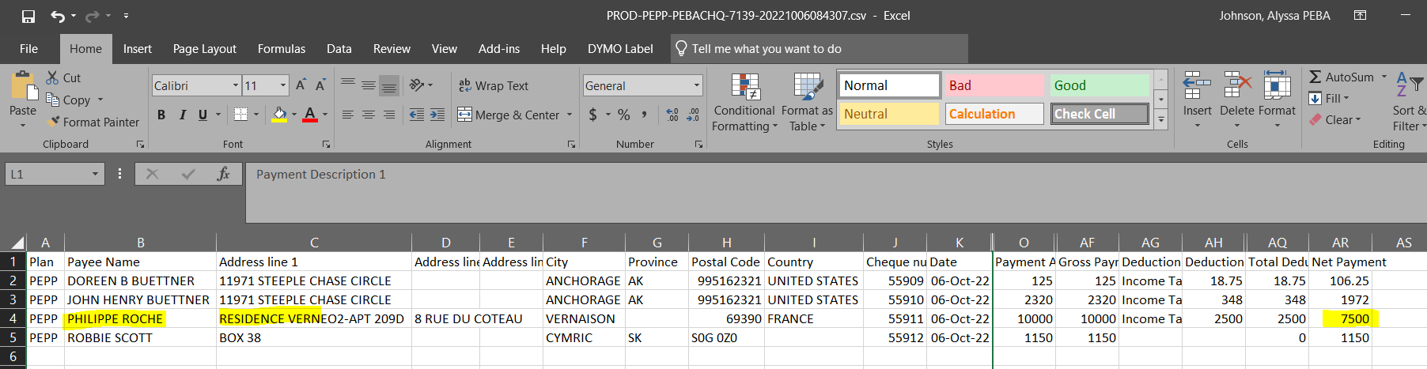

Confirmed monthly payroll report opens and amounts match Penfax:

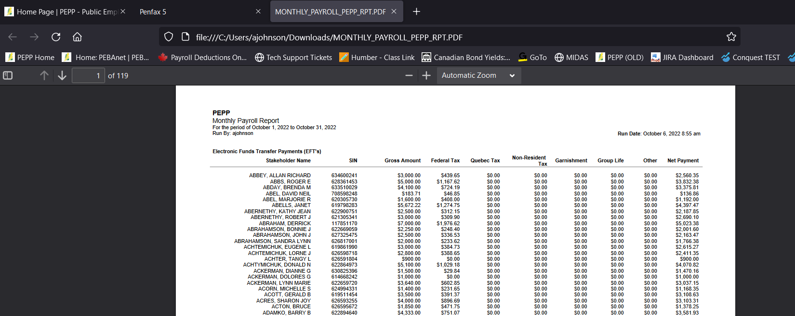





TOTAL Pmts = 5041+4 = 5045

Total $$:

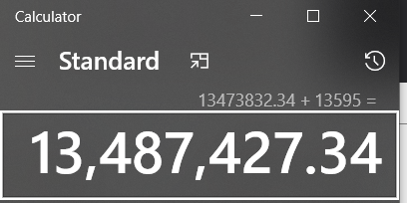

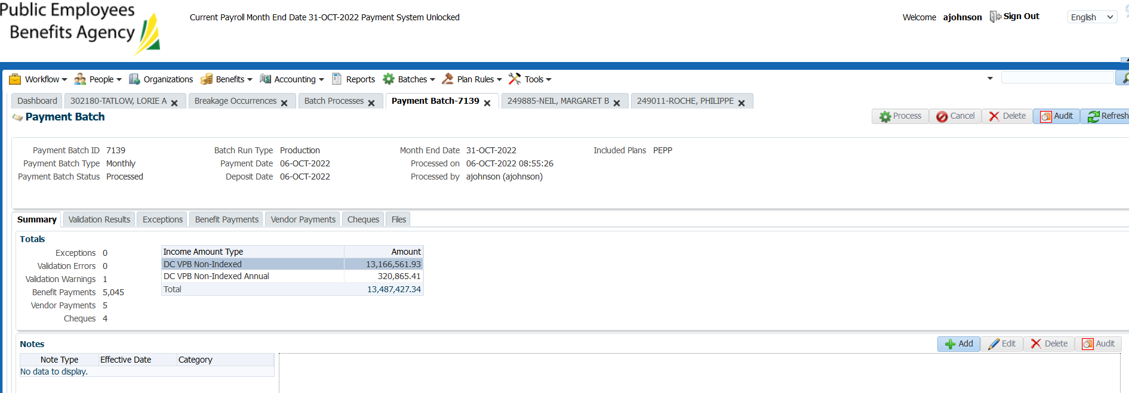

Confirm breakdown of vendor payments:

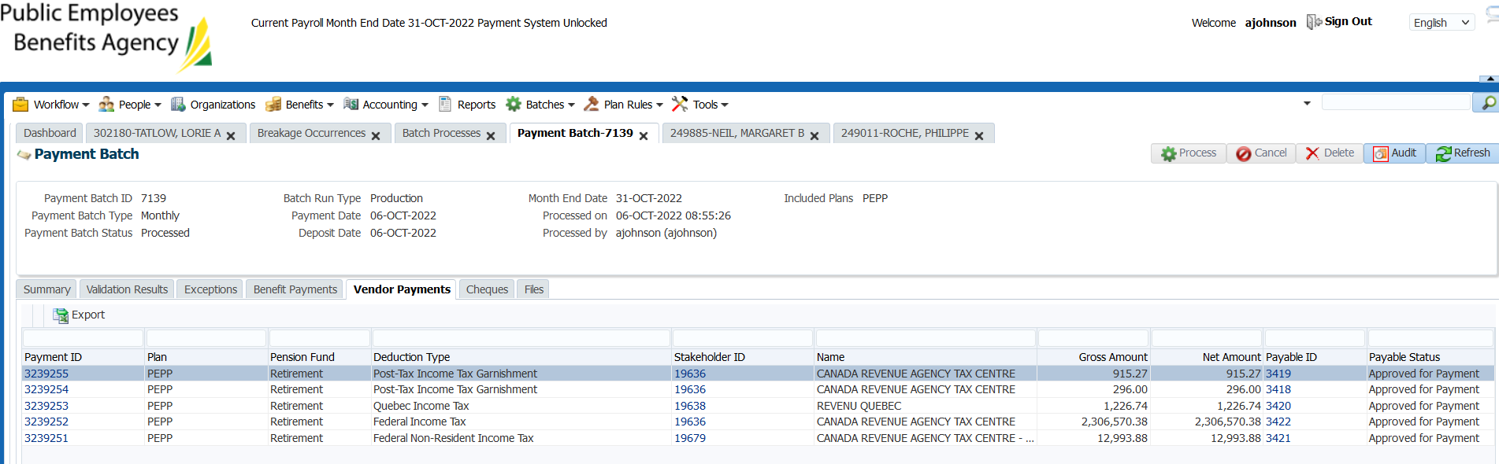

Post Tax Income Tax Garnishment = CRA requirement to pay